Технологическая карта
урока английского языка
в 5 классе
Тема: «Amazing animals»

учитель МАОУ «Школа №30»
Севрюкова Екатерина Викторовна
Тип урока: комбинированный урок
Тема модуля: Животные со всего света (7 часов)
Тема урока: Удивительные создания

Место урока в цикле: Первый урок – повторение изученного материала, введение новой лексики.

Цели урока:
1.Учебная:
- освоить новые лексические единицы по теме: «Животные» во всех видах речевой деятельности
- научиться описывать животных
- использовать в связной речи глаголов в Present Simple
2. Воспитательная:

- воспитывать любовь к животным, экологическую культуру
- воспитывать бережное отношение к природе
3. Развивающая:
- развивать коммуникативные умения обучаемых через проектную деятельность
- развивать навыки и умения в таких видах деятельности как говорение, чтение, аудирование.
- развивать умение запоминать новые слова
- развитие социокультурной компетенции
4. Социокультурная:
- приобретение знаний о животных Британии;
- знакомство с обычаями содержания и ухода за домашними животными;

Задачи урока:
- Активизировать лексику по темам «Животные» и «Части тела животных»
- Практиковать в употреблении модального глагола can, глаголов to be, to have и настоящего простого времени.
- Закрепить изученный материал в проектах
- Развивать навык работы в команде
- Воспитывать доброе отношение к животным

Технологии (ФГОС), используемые на уроке:
- игровые технологии (ролевые игры, командные)
- личностно-ориентированный подход
3) дифференцированный подход
4) коммуникативный метод (Communicative Approach),
5) метод коммуникативных заданий (Task - Based Learning)

Представление о результатах:
1. Личностные результаты: этическое оценивание информации о зарубежных странах;
2. Метапредметные результаты:
- регулятивные УУД: умение формулировать учебную задачу, планирование деятельности при работе в парах и группах, самоконтроль и самокоррекция, способность к самооценке и рефлексии;
- познавательные УУД: умение осознанно строить высказывание по теме в устной и письменной форме;
- коммуникативные УУД: умение слушать и вступать в диалог;
- участвовать в коллективном обсуждении.
3. Предметные результаты: соответствуют учебной цели урока.

Языковой материал.
Активнаялексика:
carry, cobra, dangerous, deer, leopard, lion, rhino, tiger, use

Пассивная лексика:
Stripes, hides, dangerous, head, heavy, trunks, horn, alone, mud

Грамматический материал:
Present Simple

Фонетический материал:
-(e) s [s],[z ], [iz]

Оснащение урока:
- Учебник « Английский в фокусе» для 5класса. Авторы: Ю.Е.Ваулина, В.Эванс, Дж.Дули, О.Е. Подоляко. Москва. ExpressPublishing/ Просвещение, 2011
- Рабочая тетрадь « Английский в фокусе» для 5класса. Авторы: Ю.Е.Ваулина, В.Эванс, Дж.Дули, О.Е. Подоляко. Москва. ExpressPublishing/ Просвещение, 2012
- Дидактический материал на тренировку лексики и грамматического материала
- Словарь в конце учебника
- Грамматический справочник к модулю 5
- Мультимедийная презентация в Power Point (приложение)
- Компьютер, проектор, УМК, карточки с изображением животных и тексты; задания по аудированию, видеофайл с песней

Методы обучения: словесные (беседа), наглядные (просмотр слайдов презентации, видео), практические (аудирование, говорение,чтение).
Литература для учителя:
- Учебник « Английский в фокусе» для 5 класса. Авторы: Ю.Е.Ваулина, В.Эванс, Дж.Дули, О.Е.Подоляко. Москва. ExpressPublishing/ Просвещение, 2011.
- Рабочая тетрадь"Английский в фокусе" для 5 класса (Spotlight6),Вирджиния Эванс, Дженни Дули,Издатель: Просвещение,ExpressPublishing,2012
- Книга для учителя"Английский в фокусе" для 6класса (Spotlight6),Вирджиния Эванс, Дженни Дули,Издатель: Просвещение,ExpressPublishing,2012
- Аудио CD к учебнику"Английский в фокусе" для 6класса (Spotlight6),Вирджиния Эванс, Дженни Дули,Издатель: Просвещение,ExpressPublishing,2012
Структура урока:
1. Организационный момент-5 мин..
Приветствие. Создание положительного эмоционального настроя.
Warming-up activities
T: Good morning, dear boys and girls! Glad to see you. So, let’s start our
lesson.
2. Сообщение темы и цели урока. – 0,5 мин.
We are going to speak about animals
Речевая и фонетическая зарядка. Введение в тему. – 4мин.
Animals are amazing creatures.
Repeat after me
Crocodile, tiger, zebra, lion, elephant, bear
Do you like animals? What is your favourite animal?
Целеполагание - 0,5мин.
3. Основная часть урока.
4. Актуализация знаний по теме-5-7 мин.

Repeat the old words and learn new. Topic “Animals”.
Look at the book p.66 ex.2 and repeat the names of the animals. Slide 2.
Учащиеся называют животных.

Predicting the content of a text. Page 66 ex.3.
Look at the title and guess what the text is about.
Совершенствование навыков чтения , говорения, граматических умений-7-10 мин.

Reading for specific information.
Answer the questions (Slide 3.) Pupils read the questions, find information in the text and answer.
Предлагается объяснить значение выделенных слов в тексте. Можно объяснить с помощью синонимов, антонимов, мимикой, жестами.
Слова: stripes, hides, hunts, dangerous, head, heavy, trunks, horn, alone, mud.

Group work. Divide class into 4 groups, give them the text about the animals.
Tigers, lions, giraffes, elephants. (Приложение 1,2). They read the text and complete the table. (Slide 4).

Speaking. Discussing the content of the texts.
Each group talks about tigers, lions, giraffes, elephants using the table. (Slide 4).

Grammar. Presenting the Present Simple. (Slide 5). Do exercise 7, page 67.
Put the verbs into correct form. (Slide 6).

5. Совершенствование навыков аудирования -5-7мин.

Listening. Listen to the song and answer the questions. (Slide 7-8).
6. Заключение.
- Подведение итогов урока
- Рефлексия
Thank you for the lesson.
Did you like lesson?
What new information about animals did you know?
What part of the lesson did you like?

- Домашнее задание
Write about your favourite animal.

Технологическая карта урока:
Виды деятельности учителя |  |  | Организация деятельности обучающихся |  |  |  | Деятельность с использованием ИКТ
1.Организационный момент.
Задача: проверка готовности к уроку.
Форма контроля: педагогическое наблюдение.

1.Приветствие обучающихся.  Good morning, children. You may sit down.  2. Проверка наличия принадлеж-ностей для урока.Glad to see you! Is anybody absent today? That’s a pity Sveta is absent! Is she ill? No? Oh, I see – she has gone to Moscow! Are you OK? Are you ready to speak and do your best at the lesson? OK? That’s nice of you!  Answer my questions, please.  - What date is it today?  - What date was yesterday?  - What day is it today?  - What day was yesterday?  - What is your favourite day of the week?  - What is the weather like today?  - What was the weather like yesterday? |  |  |  | 1.Приветствие учителя.  2.Показывают готовность к уроку.  - включение учащихся в речевую деятельность через микробеседу; (составление мини-диалогов о событиях прошедшего дня).  - актуализация имеющегося опыта  - student’s answers.
2.Речевая, фонетическая разминка.
Введение в тему урока. Целеполагание
Задача: активизация лексических единиц,
тренировка употребления в речи высказываний по теме урока
Форма контроля: индивидуальный контроль
3. Фонетическая зарядка.  Let's start with our phonetic drill. Repeat after me  Crocodile, tiger, zebra, lion, elephant, bear  Do you like animals? What is your favourite animal?  Сообщение темы и цели урока.  -We are going to speak about animals But before we start let’s do the phonetic exercises. The task is to pronounce Russian proverbs with English pronunciation.  -За двумя зайцами погонишься - ни одного не поймаешь  -Без труда не вытащишь и рыбку из пруда  -Каждая лягушка своё болото хвалит  -Цыплят по осени считают  -Соловья баснями не кормят  What is common in all these proverbs? (All of them are about animals)  So, what is the topic of our lesson? (Amazing animals)  Целеполагание.  Look at the screen. The aims of our lesson are:  - To revise vocabulary of different topics such as: animals, parts of the body and so on.  - To use the modal verb CAN, the verb TO BE and the Present Simple Tense.  - To practice in English  - To make a project |  |  | Crocodile, tiger, zebra, lion, elephant, bear  - student’s answers. |  |  |  | 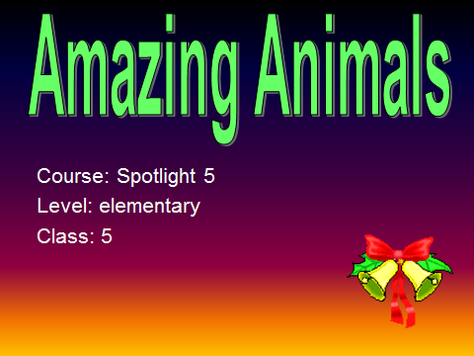  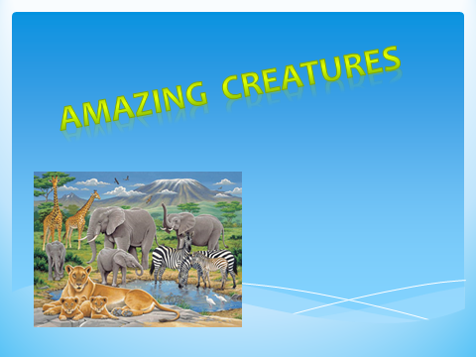
3.Актуализация
Задача:активизация лексических единиц,
научиться описывать животных
использовать в связной речи глаголов в Present Simple
Форма контроля: индивидуальный контроль, самоконтроль
1.Repeat the old words and learn new. Topic “Animals”.  Look at the book p.66 ex.2 and repeat the names of the animals.  2. There are 3 teams in our class, each team has a team-leader, so we will compete during the lesson and who will get more points will be a winner. OK? Let’s start.  3.What can we do in English? We can name animals, describe animals and parts of their body, write a fact file about an animal and sing songs. And at the end of the lesson we’ll make the project “Amazing Animals’ album”  4. Answer the questions. (Pictures of the animals)  What is it? Where does it live?  What has it got? What does it like to eat?  5.Predicting the content of a text. Page 66 ex.3.  Look at the title and guess what the text is about.  6.Reading for specific information.  Answer the questions .  Pupils read the questions, find information in the text and answer.  Предлагается объяснить значение выделенных слов в тексте. Можно объяснить с помощью синонимов, антонимов, мимикой, жестами.  7.Group work. Divide class into 4 groups, give them the text about the animals.  Tigers, lions, giraffes, elephants.  They read the text and complete the table. |  | Учащиеся называют животных.  It’s a … .  It’s….  It lives … .  It has got … .  It can … .  It likes to eat … .  stripes, hides, hunts, dangerous, head, heavy, trunks, horn, alone, mud.  Group1 Tigers  A Tiger is a powerful carnivore, a hunter with sharp teeth, strong jaws, and a very agile body. Tigers do not live in Africa. They live in Asia. Tigers are an endangered species because their habitat is disappearing.  Tigers can live to 20 years of age in zoos but only 15 years in the wild. Most wild tigers do not live that long. Only half of all cubs survive to independence from their mother at about two years of age. Tigers are great swimmers. The roar of a tiger can be heard over a mile away. They are the largest of all cats with males growing up to 3.3 metres long and weighing up to 180-250 kilograms.  Most tigers have more than 100 stripes. Their stripes are much like a fingerprint, because no two tigers are exactly alike. Its favourite foods include elk, deer, wild boar, lynx and bear; wild boar makes up more than half of its diet. They will also eat fish, rabbits. Tigers can run very fast reaching speeds of up to 50 mph, however, they can only maintain this speed over short distances.  Group2 Giraffes  Giraffes are the tallest land mammals. A male giraffe grows to 3.8-4.7m. and weigh is about 800 кg . Their necks and legs alone are each about 6 feet long and their tails can grow to 3.1 m length. Their coat is short and sandy coloured with various shaped patches coloured different shades of brown. Their mane is short and it stands upright and they have a dark tassel of hair at the tip of their tail. They live for 25 years, in the zoo 28.  Giraffes are found in Africa but are becoming increasingly rare in the west. They live on open grasslands that are scattered with trees. Giraffes feed mainly from acacia and commiphora (myrrh) trees. Because of their height they easily pluck the leaves from the tops of these tall trees. A Giraffe can eat up to 50 Kgs of leaves per day.  Because of their height they easily pluck the leaves from the tops of these tall trees.  Group3 Elephants  Elephants are wonderful animals! They are the largest mammals in the world that live on land. There are two kinds of elephants; African and Asian. Asian elephants have smaller ears and shorter tusks than African elephants. The African elephant is bigger and taller than the Asian elephant. Adult males weigh is between 2.0-6.5 tons.  Females are smaller (3 and 4 tons). Elephants smell, drink, eat, and wash themselves with their long trunks. Elephants are capable of pulling up to 11.5 liters (3 gallons) of water into the trunk to be sprayed into the mouth for drinking or onto the back for bathing. Elephants eat grass, small branches, and bark from trees. They especially like leaves from the top branches. They get the leaves by pushing down the trees with their large heads and bodies. Then they get the bark by scraping it with their sharp tusks. Most elephants live in the grasslands of Africa and in the forests of Asia.  They live for 60 years.  Group4 Lions  The Lion is described as large, carnivorous mammal, a symbol of power. Lions are the second largest feline.  Lions have a short tawny coat, a tufted tail, and male lions have a heavy mane  around the head and neck. Lions are native to Africa and Northwest India.  Lions are found in savannas, grassland, dense bush, woodlands. Lions are the laziest of the big cats. They sleep 16-20 hours a day. They live for 13 years in captivity.  They are good hunters. Mice, lizards, tortoises, antelopes form part of a lions diet.  Fully grown males reach the height of 4 feet. An adult male weighs between 150-225кг. Lions are active during and at night but they prefer hunting at night.  A lion can run up to a maximum speed of 80 km per hour. |  |  |  | 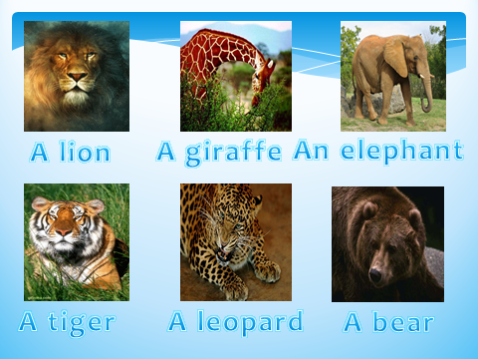  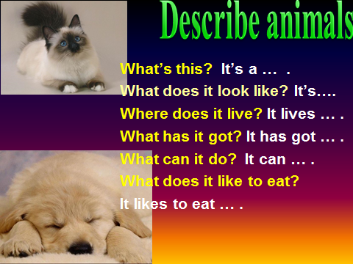  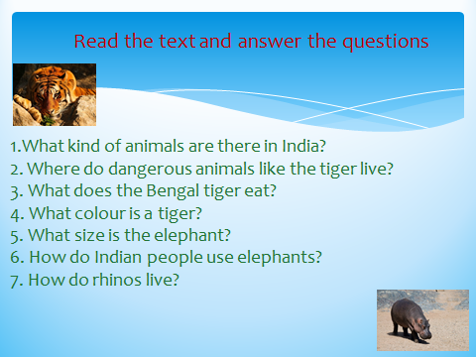  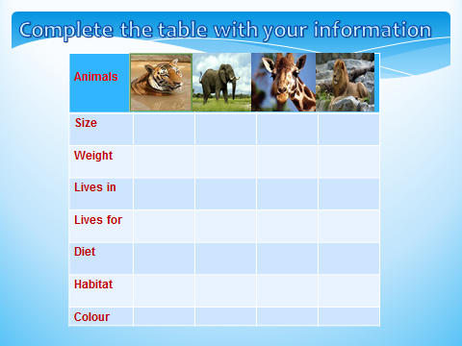
4. Совершенствование грамматического навыка в аудировании и говорении

Задача:
развивать коммуникативные умения обучаемых через проектную деятельность
развивать навыки и умения в таких видах деятельности как говорение, чтение.
развивать умение запоминать новые слова
Форма контроля: индивидуальный контроль, самоконтроль

8. Speaking. Discussing the content of the texts.  Each group talks about tigers, lions, giraffes, elephants using the table.  9.Grammar. Presenting the Present Simple Do exercise 7, page 67.  Put the verbs into correct form. | students are listening and answering the |  |  |  | 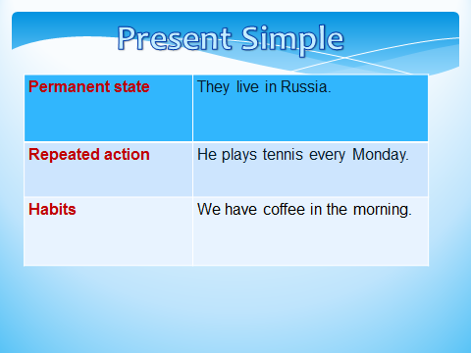  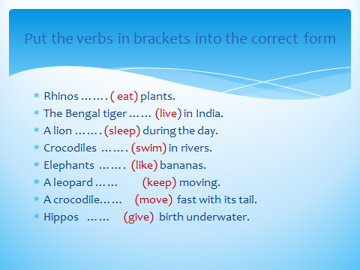
5.Совершенствование навыка аудирования
Задача:
развивать навыки и умения в аудировании
развивать умение запоминать новые слова
Форма контроля: Индивидуальный контроль

10.Listening. Listen to the song and answer the questions. |  |  | 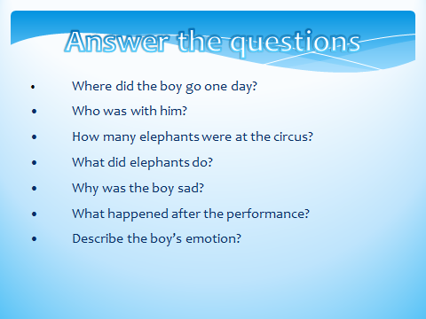
7.Интеграция полученных знаний:
Задача: суммировать полученные знания,
отработать навык употребления лексических и грамматических единиц
Форма контроля: Скрытый контроль,
опрос учащихся, фронтальный опрос.
11. Подведение итогов урока  You are working and speaking very well. Butourlessonis nearly over. Let’s find out what we have learned at this lesson.  Рефлексия  What new information about animals did you know?  What part of the lesson did you like?  Did you like lesson?  Homework .  Now the lesson is over! Thank you very much for your job! Look at the board- it’s for you, my students!  - объявление д/з, объяснения д.з  Write about your favourite animal  The lesson is over. Thank you. Bye. |  | - подведение итогов урока и выставление оценок;  узнали новые слова и словосочетания; научились произносить новые слова; познакомились с информацией о животных  /учащиеся анализируют свою работу/  Записывают домашнее задание.

